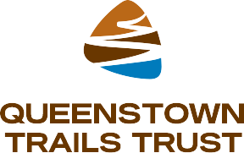
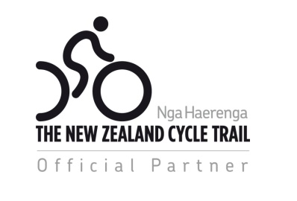
OFFICIAL PARTNER PROGRAMME
#trustedtrailpartners

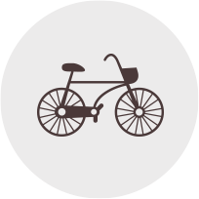

QUEENSTOWN TRAIL AND THE CYCLE TOURISM OPPORTUNITY

A big thank you! Because of support from our Official Partner Programme the magnificent Queenstown Trail which took $6m to construct has won the hearts of locals and visitors. Over 1 Million users have enjoyed the trail since its opening in October 2012, making it one of the most used trails in the country!

The Official Partner Programme increases New Zealand’s credibility as a cycling and walking destination which is good news for the Queenstown Trail and local businesses. The trail has created incremental demand for services such as transport, tours, accommodation, bike hire, dining, wine and activities - the goal of the programme is to increase turnover for local businesses, create employment and opportunity and provide tourists with trusted recommendations, endorsed by the Queenstown Trail and NZ Cycle Trail. Cycle tourists expect a high level of customer service and are actively looking for local recommendations, the Official Partner programme is the perfect catalyst for this and businesses can leverage lucrative cycle tourism by becoming an Official Partner of the Queenstown Trail, one of New Zealand’s 23 Great Rides.

Cycle tourists spend more on their visit ($3800) compared with the average international tourist ($2500) – TNZ cycle tourism market profile, 2013

THE OFFICIAL PARTNER PROGRAMME

The Queenstown Trails are attracting visitors from all around the world! Our website and social media channels offer information, advice and recommendations to assist in holiday planning. Our visitors are actively researching the best places to eat, stay, hire or purchase gear, transport, tours and entertainment.

By becoming an Official Partner, you can leverage the cycle tourism boom and drive high spending cycle tourists to your business.

We offer two programme options – Official Partner status or upgrade to Official Partner Plus status for a little more razzle dazzle. See table below for inclusions, benefits and costs.

PROGRAMME INCLUSIONS, BENEFITS AND COSTS

Inclusion | Benefit to Official Partner | Official Partner  $295 per annum | Official Partner Plus  $395 per annum
Business listing on Queenstown Trail website -  http://queenstowntrail.co.nz/trail-directory/ | Our Trail Directory receives over 25k page views each year, that’s 25k potential new customers for our Official Partners
Business listing on NZ Cycle Trail website - http://nzcycletrail.com/partners/ | Profiling on this national website will give you even more coverage and access to cycle tourists actively looking to plan a trip
Licence to use Nga Haerenga – The New Zealand Cycle Trail (NZCT) logo and the Queenstown Trails Trust logo at your business, on your website and printed materials | This clearly advises trail visitors and local users that you have been evaluated and meet service requirements as outlined by NZCT. In other words, you are a #trustedtrailpartner
As an Official Partner you will be invited to promote yourself as part of the Official NZCT Product Directory | Produced annually and is available online and for use at the annual TRENZ trade show. Opening up a potentially new trade audience for Official Partners
Promotion of Official Partner news, events or special offers via Queenstown Trails Facebook page  #trustedtrailpartner | As of September 2016, the Queenstown Trail Facebook page has 1422 likes and post reach of over 10k per month, each of our posts reach a minimum of approx. 400 people rising to over 2k, that’s huge reach for your content
Your business location plotted on the Official Queenstown Trail Map | 15,000 initial print run, distributed via iSites, events, Official Partner outlets and QLDC locations (libraries, event centre, council chambers). Ask us about additional map advertising opportunities.
Invitation to attend our annual NZCT/QTT tourism marketing workshop | Giving our partners insight into how to leverage the lucrative cycle tourism boom
Opportunity to feature in the Queenstown Trail blog #talesfromthetrail | Which is promoted via Facebook (upto 1.7k reach!) and our eNews (our blog receives an average of 25% of all newsletter clicks)
Promotion in Trail Talk, our bi-monthly eNewsletter (max 4 offers per newsletter) | Advertise a news story, offer or promotion in our bi-monthly newsletter, which is well received by over 1500 ‘Friends of the Trust’ with a fantastic open rate of 45%
Banner ad in Trail Talk, our bi-monthly eNewsletter (Max 2 per newsletter) | Banner ad space in bi-monthly newsletter, sent to over 1500 ‘Friends of the Trust, with a fantastic open rate of 45%
First opportunity to joint venture with specific Queenstown Trail Marketing opportunities | Giving a direct link into cycle tourism market

100% of your membership fee will go to the Queenstown Trail for ongoing marketing and promotion of the Queenstown Trail.

What our Official Partners have to say about the programme…

‘’ Around The Basin is privileged to have access to the Queenstown Trail network and the fortune that is a world class cycle trail, without it we would not have a business .’’
- Steve Norton, Owner Operator, Around The Basin

‘’ For people who are looking for a leisurely ride we have a huge range of trails and tracks that we can now recommend to our guests that will take them through breathe taking scenery in and around Queenstown. It’s very refreshing to see this new market open up so many new opportunities for us all in the hospitality industry .’’
- Chris Ehmann, GM, Hilton Queenstown Resort and Spa

Next steps

Sign up and pay via our website HERE

- Review terms and conditions as this will form the legally binding agreement between us in the event that your application is successful.

- Once The Queenstown Trails Trust has received your completed application and payment, it will notify you whether your application has been successful. Please note that it is at the Queenstown Trails Trust’s discretion whether to grant you a licence or not.

- If your application has been successful, you will be sent up:

  - A copy of the Official Partner logo, details on how to download the logo and accompanying guidelines, and Official Partner window sticker and receipt for payment.
  - Details regarding what content you need to send us for your online listing

- PLEASE NOTE that the fee specified above applies to a 12 month period.

- If your application has not been successful, you will be notified and your payment (if paid by direct debit) will be refunded.

